KRUSHI KA RAJ

Abstract:
The project outlines a smart farming solution designed to minimize early-stage crop loss in chilly farming by implementing an automated system for seed planting, soil monitoring and irrigation. Traditional methods often lead to uneven seed placement, poor irrigation and inefficient use of resources, resulting in significant crop loss.
The system utilizes an Arduino microcontroller integrated with the Blynk IoT platform to automate planting, ensuring optimal seed germination and growth.
Mechanical seed deployment includes solenoid valves control precise seed placement, maintaining uniform depth and spacing.
Soil moisture monitoring includes capacitive soil moisture sensors provide real time data, enabling planting only under favorable conditions. Remote monitoring and control useful for farmers, can access real-time soil conditions and system status through a smartphone app.
Fertilizer and Pesticide Sprinkler module include nutrients and pest control directly to the root zone, reducing waste and preventing root disease.
The system can also be powered by renewable energy sources like solar panels. Future developments may include AI for seed strength analysis and machine learning for performance optimization. This smart farming tool aims to increase crop yields, reduce labor costs, provide a sustainable approach to agriculture, particularly benefiting farmers in developing regions. By integrating IoT, automation, the project addresses key challenges in farming, ultimately contributing to improved food security globally.
Problem Statement:
In traditional agriculture, the process of seed sowing in chilly farming is labor-intensive, time-consuming, and often inconsistent, leading to uneven crop growth and inefficient land use. Farmers, particularly those in developing regions, lack access to tools that ensure proper seed spacing, depth, and coverage, which can result in poor germination rates, reduced crop yields, wasted resources like water and fertilizer and , increases root and stem disease this may leads to crop loss in early stage only. Additionally, the manual sowing process often contributes to soil compaction and erosion, further affecting crop quality. There is a need for a solution that can automate or optimize the seed sowing process, ensuring precise placement, reducing labor costs, improving yield, and promoting sustainable farming practices.
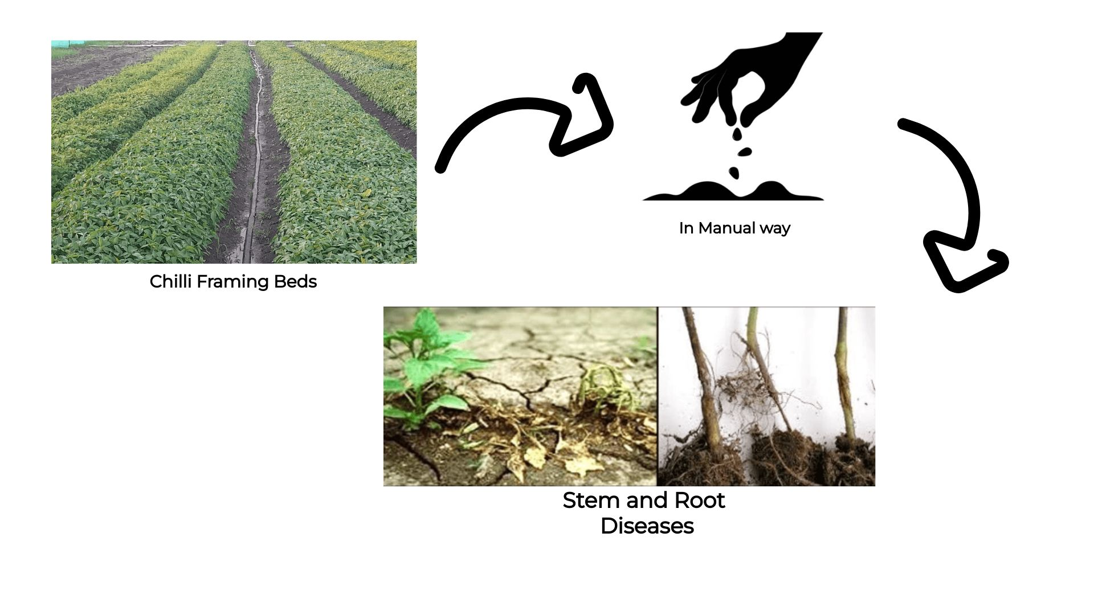
Description:
The project focuses on a smart farming solution for chilly farming, addressing key challenges like uneven seed placement and inefficient resource use. It uses an Arduino-based automated system with solenoid valves for precise seed planting, and soil moisture sensors to ensure seeds are planted only in optimal conditions. Integrated with the Blynk IoT platform, it allows remote monitoring of soil conditions and irrigation. The system includes a targeted nutrient and pesticide delivery module, reducing waste and preventing plant diseases. It offers a sustainable, scalable solution aimed at increasing crop yields and efficiency.
Solution:
The Krushi Ka Raj prototype functions as an automated and intelligent seeding system designed to enhance crop productivity through precision control. Initially, capacitive soil moisture sensors continuously monitor the moisture content of the soil and send real-time data to the farmer via a smartphone application. When the soil conditions are deemed favorable for planting, the system notifies the farmer. Based on the farmer’s command, the seeding process begins using solenoid valves that ensure uniform seed placement at consistent depth and spacing. Simultaneously, a remote-control mechanism allows the farmer to adjust seed spacing and start or stop the process as desired. In parallel, the fertilizer and pesticide sprinkling module activates to apply nutrients and pest control directly to the root zone, ensuring plant health and reducing waste. The integrated drip irrigation technology delivers precise water and nutrient amounts, minimizing resource wastage and optimizing soil moisture for seed germination. Through this automated mechanism, the system enhances seeding accuracy, conserves resources, and reduces manual effort while providing farmers with full control and real-time updates via IoT connectivity.
Key Points:
- Soil moisture sensors monitor and report real-time soil conditions.
- Farmer receives alerts on soil readiness for seeding.
- Solenoid valves ensure uniform seed placement and depth.
- Remote control allows farmer to manage seed spacing and operation.
- Sprinkler module applies fertilizers and pesticides efficiently.
- Drip irrigation ensures precise water and nutrient delivery.
- IoT integration enables real-time monitoring and control via smartphone.

Results:
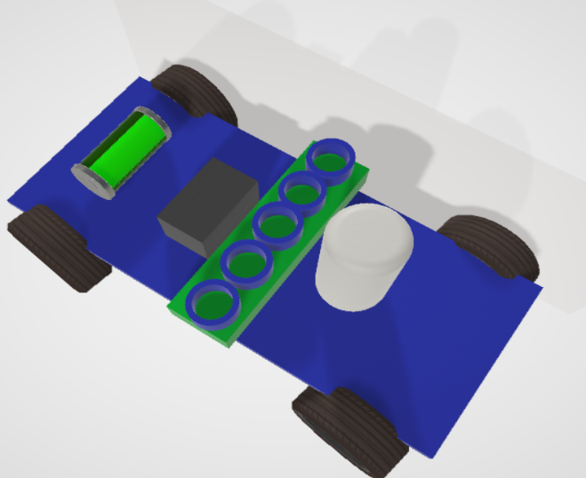
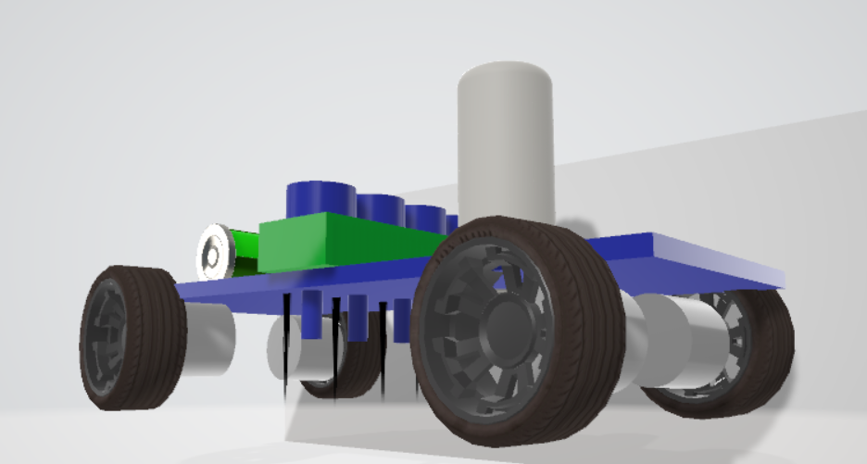

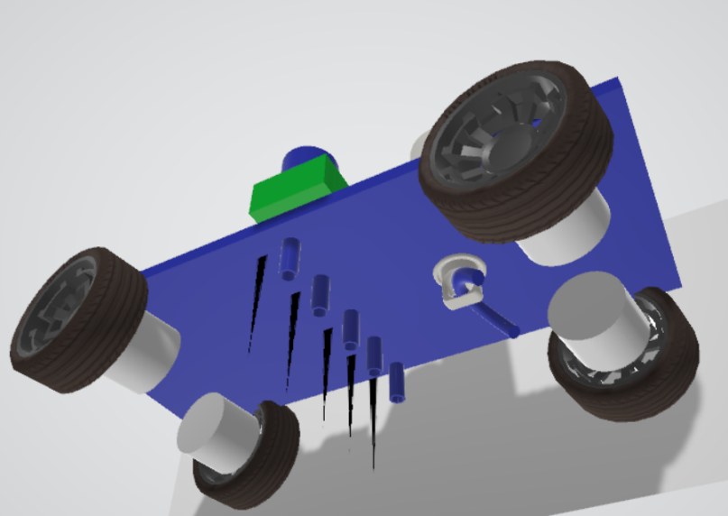
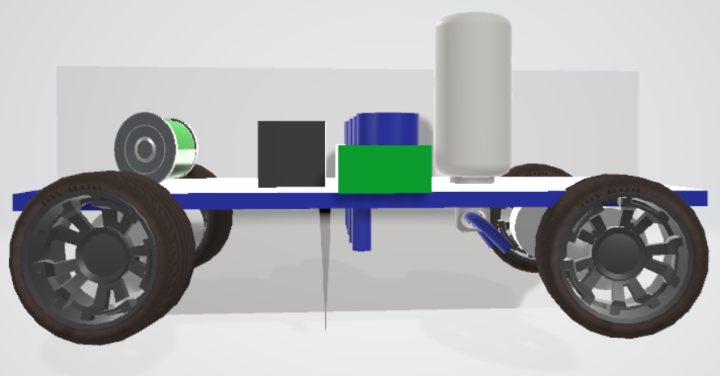
Claims:
- The system offers automated seed deployment with solenoid valves, ensuring uniform spacing and depth for better crop growth.
- It uses real-time soil moisture sensors to find the best seeding conditions.
- Farmers can control seeding remotely, starting or stopping the process through a smartphone app.
- The system includes an IoT-based monitoring and control module, giving farmers access to live data and control over field conditions.
- Its integrated fertilizer and pesticide sprinkler module sends nutrients and pest control directly to the root zone, which cuts down chemical waste and helps prevent root diseases.
- A drip irrigation system ensures accurate water and nutrient delivery, reducing waste and improving plant health.
- The solution allows farmers to customize seed spacing and depth to fit their needs.
- It helps to use resources more efficiently, lowering water, fertilizer, and pesticide use by up to 30 to 40 percent.
- The system minimizes manual labor and reduces reliance on people by automating various farming tasks.
- The IoT connectivity feature enables data logging and cloud syncing, which helps with long-term analysis and insights for improving yields.
- The solution is scalable and modular, so it can adapt to different crop types and farm sizes.
- It supports sustainable farming by encouraging smart water use, lowering chemical runoff, and enhancing soil health.
Target Market:
1. Who are the customers?
- Small & medium farmers who may not be able to continually hire labor, want better yields, and are becoming aware of precision/Agri‐tech solutions.
- Large farms / agribusinesses that can invest in automation, and that cultivate large acreages where efficiency gains make automation viable.
- Agri‐cooperatives, contract farming operations that manage multiple farm plots and have interest in standardized output.
- Government / public sector: Agricultural extension programs, subsidies, rural support; schemes promoting precision farming, water / input efficiency; could be buyers or facilitators.
- Commercial greenhouse / high‐value crop farms: specialist growers who care about uniformity, disease control (so interested in pesticide/fertilizer application module), precise irrigation.
2. Geographic markets
- India (states with large agricultural output, irrigated farms, progressive farmer base).
- South Asia (Pakistan, Bangladesh, Nepal, Sri Lanka).
- Southeast Asia.
- Africa (where cost pressures are high, but adoption may be slower).
- Developed countries (for specialized or premium version).
3. Use‐cases / segments
- Crops requiring precise spacing / depth (vegetables, cereals).
- Regions with seasonal moisture constraints; also places where irrigation / water is scarce.
- Where fertilizer/pesticide overuse is common (so savings are an incentive).

Future Extensions:
- Integration of AI-based crop recommendations to analyze soil, moisture, and weather data for selecting suitable crops.
- Implementation of automated path navigation using GPS and ultrasonic sensors for self-guided field movement.
- Weather prediction integration adjusts irrigation and seeding schedules based on real-time forecasts.
- Addition of voice and gesture control features makes the system easier to operate through the mobile app.
- Development of a data analytics dashboard visualizes soil health, crop growth, and resource use trends.
- Incorporation of AI-based disease and pest detection uses camera modules for early diagnosis.
- Transition to solar-powered operation improves energy efficiency and works in remote locations.
- Improvement of multi-crop adaptability supports various seed types and planting configurations.
Business Model:
Component | Description
Value Proposition | • Automated and accurate seed placement that promotes uniform crop growth.  • Real-time soil moisture monitoring with remote control via IoT.  • Reduces water, fertilizer, and pesticide waste.  • Improves productivity and decision-making through data insights.  • An affordable, scalable, and user-friendly solution for all farm sizes.
Customer Segments | • Individual farmers (small, medium, large scale).  • Agricultural cooperatives and contract farming groups.  • Smart farming initiatives led by government and NGOs.  • Agricultural universities and research organizations.
Key Activities | • Designing and making IoT-based seeding and irrigation kits.  • Developing a mobile app for monitoring and control.  • Installation, training, and support after the sale.  • Research and development for AI integration and performance improvement.
Key Resources | • IoT components, including sensors, solenoid valves, and controllers.  • A cloud and mobile platform for managing data.  • A skilled technical and support team.  • Partnerships with hardware suppliers and agricultural agencies.
Distribution Channels | • Direct sales through exhibitions and workshops.  • Partnerships with cooperatives and government programs.  • Online platforms and e-commerce sites.  • Digital marketing and agricultural tech forums.
Revenue Streams | • Sales of hardware, including smart farming kits and add-ons.  • Subscription fees for IoT monitoring and analytics services.  • Annual maintenance and support contracts.  • Collaborations with institutions and government entities.  • Pay-per-use or leasing options for small farmers. Cost Structure
Cost Structure | • Production and assembly of hardware.  • Software development and cloud maintenance.  • Marketing, distribution, and training costs.  • Maintenance and technical support services.

Conclusion:
It demonstrates the transformative potential of IoT and automation in agriculture. By integrating precise mechanical control, real-time monitoring, remote accessibility, the system significantly enhances efficiently and sustainability in chilly farming. It empowers farmers with actionable insights, minimizes early-stage crop loss, the system could evolve into a fully autonomous farming assistant, shaping the future of smart agriculture.
Team Formation:
Name | Responsibility
Vazrala Udaya Bhaskar Reddy | Team Lead - Research & Documentation, Testing, Implementation.
Pasumarthi Harshavardhan | Hardware Engineer - Circuit Design, System Design, Report Writing.
Kondepogu Chandu | Software Developer - IoT Integration and Mobile app Connectivity.

